**Milestone 1 Submission (README)**

**Team Name:** AutoCropper

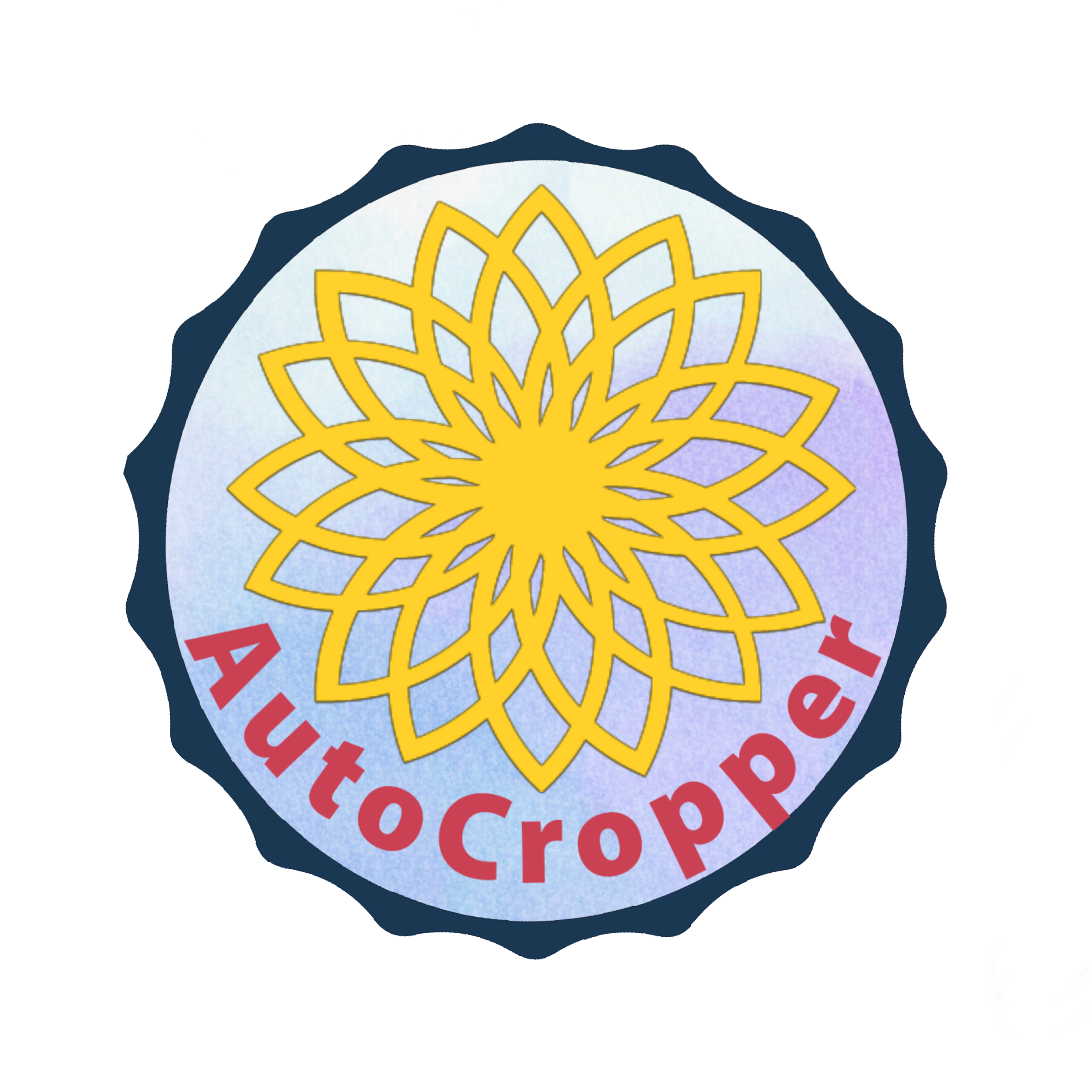

**Proposed Level of Achievement:**

Artemis

**Motivation**

As the **global agricultural workforce is diminishing** every year, further stimulated by the shift to higher skilled and more lucrative jobs, there is a **greater need for more automated crop growing processes** with a low demand for human labour. Furthermore, with a rapidly growing population, there has been an **exponential increase in the demand for food supplies**.

Such a demand is further exacerbated by **climate change** which greatly enforces the need to adopt optimal controlled environments for ideal crop cultivation. What can we do to alleviate this pressing issue in Singapore?

**Local Context**

The Singapore government aims to produce **30% of its nutritional needs by 2030** for greater food security in anticipation of supply or price fluctuations, which once again reiterates the importance of increasing agricultural productivity. Given the Agri-Food & Veterinary Authority of Singapore’s (AVA) desire to optimize local food production, a substantial amount of funding has been dedicated to support local farmers in boosting their productivity through the investment in innovative technology. **With the growing emergence of many new local farmers**, especially in the area of urban farming, these farmers may be limited by lack of substantial funding and experience in agriculture. **So, how might we minimise the pressure faced by aspiring farmers who enter the agricultural industry in Singapore?**

**Aim**

To design an automated, computer controlled environment to enhance the productivity of crop growth and facilitate the sharing of information pertaining to crop growth amongst local producers.

**Target Audience**

Local agricultural producers who operate on a small scale, as well as aspiring individuals who intend to enter the agricultural industry.

**User Stories**

1. As an agricultural producer, I want to conduct preliminary testing for ideal crop growing conditions so that I will be able to optimise crop growth.
2. As an agricultural producer, I want to conduct experiments to identify the optimal growing conditions for new types of foreign crops that have never been cultivated in Singapore.
3. As a prospective and aspiring agricultural producer, I want to possess prior knowledge of ideal crop growing conditions so that I can avoid costly preliminary testing.
4. As a local interested in growing plants for recreation, I want to be able to cultivate my plant without much difficulty from the comfort of my home.

**Project Scope**

1. The **AutoCropper** device is a user-operated hardware for the **provision of a controlled**

**environment** for crop growth.

1. The **web application** serves as the user interface to relay information to the AutoCropper hardware. This app will also serve as a common database for users to share the information obtained from self-conducted experiments.

**AutoCropper Device:**

**Rationale:**

The primary goal would be to provide a platform for users to conduct preliminary testing on optimal crop growing conditions. This serves as an assurance to producers by ensuring greater reliability of proposed conditions for crop production before any large scale production is initiated.

**Proposed Core Features** (to be completed by early July)**:**

1. LCD display on the device that shows the current settings of the device.
2. Control 4 key conditions: Temperature, Water, Humidity, Light Intensity.
3. Full remote control from the WebApp.

**Web Application:**

**Rationale:**

Serves as a platform for users to relay information to the AutoCropper device. Functions as a common database allowing users to have access to crucial information pertaining to crop growth. This provides a greater sense of security to prospective farmers and provides more incentives for local producers to enter the industry.

**Proposed Core Features** (to be completed by mid July)**:**

1. Login system to recognise each individual user.
2. Establish access to the AutoCropper device to input desired conditions for crop cultivation and relay the information to the device.
3. User profile which contains the different types of crops each individual user has cultivated, as well as the conditions used to cultivate the crop for future reference.
4. Users will be able to browse the profiles of other users and leave feedback or comments.
5. All data and conditions pertaining to crop cultivation which have been provided by users will be stored in the user’s profile.
6. Message board system to allow users to communicate with one another.

**Program Flow**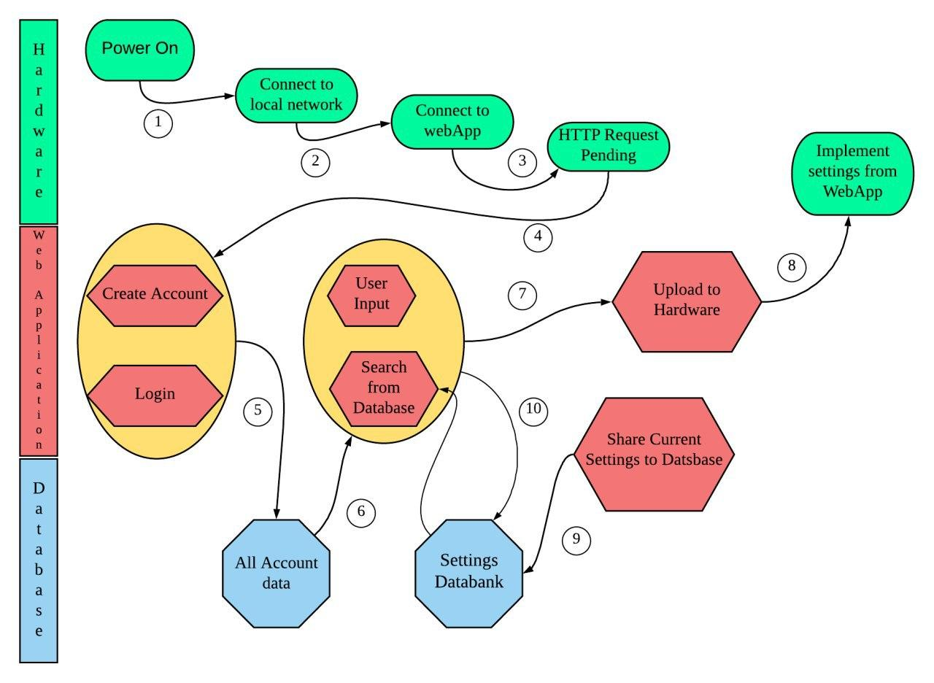

**Program Flow Overview**

1. Power on AutoCropper device.
2. Micro-controller chip automatically runs the initial sequence to connect to the local network.
3. Input the SSID and the password for the local network.
4. Send a http request to the WebApp and await the incoming http response.
5. Login or register for an account, followed by redirection to the control hub page.
6. Users can choose to browse existing data from his/her hardware, as well as view the data shared by other users.
7. Users can provide their own desired settings for crop growth or use an existing setting from the database.
8. The data will be relayed to the AutoCropper device.
9. Users can upload their customised setting to the database.
10. Data transmitted to the hardware will also be saved in the user’s database.

**AutoCropper Device Design**

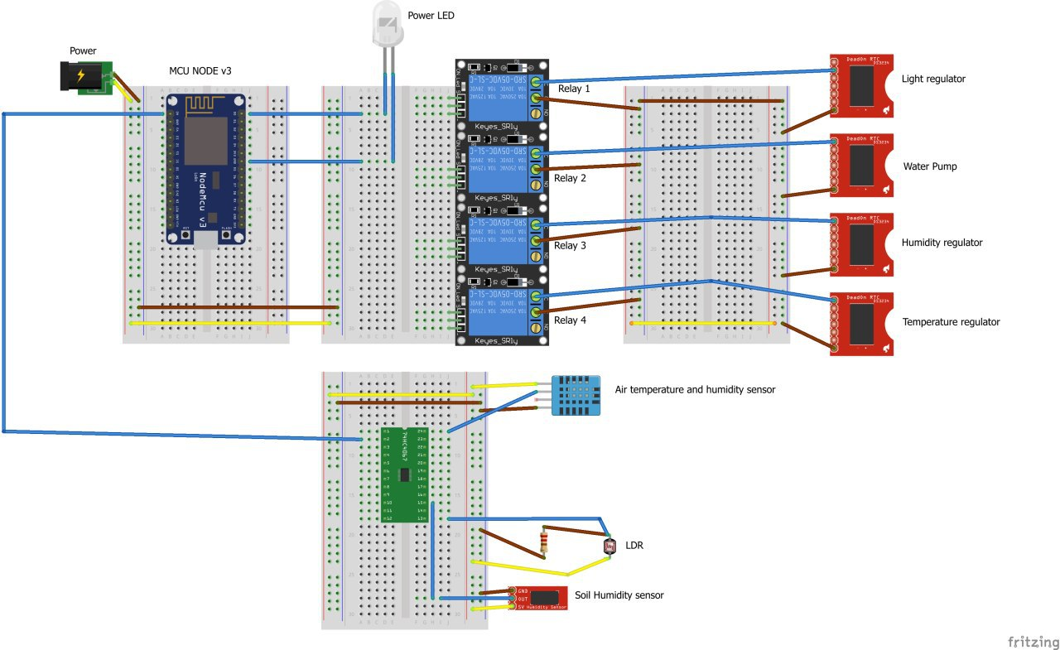

**Future Plans/Considerations for extensions**

In the long term, we plan to develop a comprehensive database that stores relevant information and data relating to crop growth. This can include the following:

* Optimal conditions to maximise growth rates and yields
* Estimated growth rate/Time to maturation
* Estimated yields
* Ideal periods to cultivate crops

Our project can be extended to accommodate other types of crops as well, including ornamental plants for recreational planters and locals who participate in allotment gardening.